CHAPTER 7: Elements, compounds and mixtures
Worksheet 7.2

Pure substances and mixtures
Student: Class:

Pure or mixture?
Consider the following substances:
tap water a cup of coffee sugar gold
distilled water chocolate salt sterling silver
sea water air oxygen gas
1. Place the substances in the appropriate column of the table below.
Pure substances | Mixture of substances
2. Pure substances may be elements (made up of one kind of atom) or compounds (made up of molecules containing at least two different types of atom). Which of the substances in the first column of the table could be described as:
(a) elements?

(b) compounds?

3. What is distilled water? Is this the same as pure water? Explain.

CHAPTER 7: Elements, compounds and mixtures

Worksheet 7.2

Get the picture?
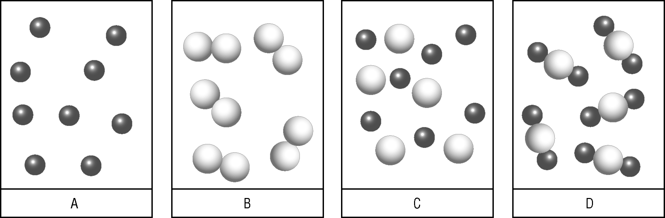

1. The pictures above represent various atom and molecule combinations.
Which of the pictures A–D could be said to describe:
(a) an element?
(b) a pure substance?
(c) a mixture?
(d) molecules?
(e) a compound?
2. Using the same sort of drawing style as in the pictures above, draw a diagram in the space
provided below that represents a mixture of different compounds.

